YUSU 1300 WEEKLY PROJECT FORMZ
NAME: | DATE:
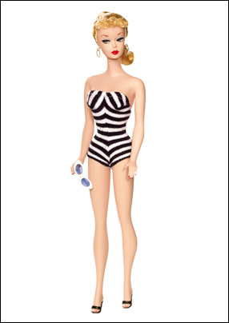
 | Here is an example of:
I found information about this subject at the following web sites:
http://xroads.virginia.edu/~class/barbie/barb2.html
IDENTIFICATION AND SIGNIFICANCE:
Ladies and Gentlemen, Please Meet the Amazing Barbie! Not everyone is aware of the fact
that Barbie began her life as a German sex toy, not as a doll for little girls. The American
toy maker Mattel bought the rights to Barbie from the German inventors after World War II
and, well, the rest is history. Of course, girls have played with dolls for hundreds and
hundreds of years, but those dolls were almost always made to look like babies. Even dolls
meant to represent adults had cartoon-like bodies, boxy and baggy. The revolutionary thing
about Barbie was that she had breasts--and pretty impressive ones at that. From sex toy to
child's toy--its an interesting transformation and one that tells us a lot about American
society in the late 1950s and early 1960s, when the ideals of womanhood, including ideas
about female sexuality, were changing and when an increasingly consumer-oriented society
began targeting girls. Oh, did I mention that this whole thing came about because a woman
business executive, something pretty rare in the corporate world of the 1950s, came up with
the whole scheme.

